Guide on How to Create Migration Scripts

Step 1: Create 4 csv files based on the migration form per tab

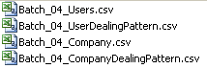
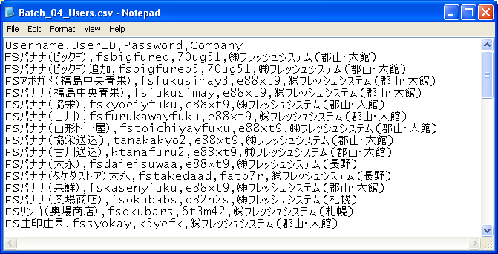
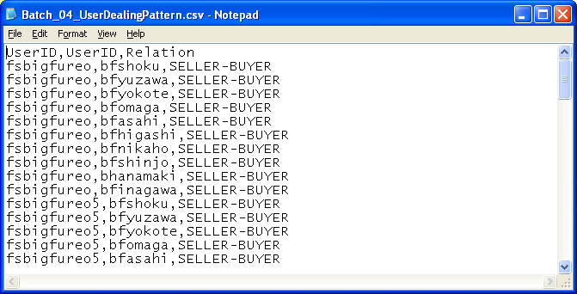
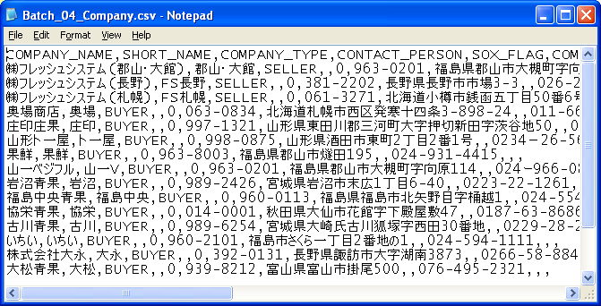
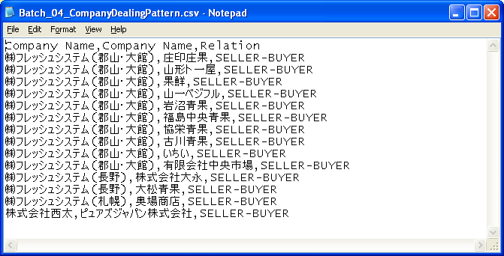

Step 2: Use the eonScriptsGenerator.jar by creating the generateScripts_[batch_number].bat to specify the file input and output.

Red – Batch Number
Blue – CSV Input file
Green – SQL Output file

java -jar eonScriptsGenerator.jar 2 /1 Batch_02_Company.csv Batch_02_Company.sql
java -jar eonScriptsGenerator.jar 2 /2 Batch_02_CompanyDealingPattern.csv Batch_02_CompanyDealingPattern.sql
java -jar eonScriptsGenerator.jar 2 /3 Batch_02_Users.csv Batch_02_Users.sql
java -jar eonScriptsGenerator.jar 2 /4 Batch_02_UserDealingPattern.csv Batch_02_UserDealingPattern.sql

java -jar eonScriptsGenerator.jar 4 /1 Batch_04_Company.csv Batch_04_Company.sql
java -jar eonScriptsGenerator.jar 4 /2 Batch_04_CompanyDealingPattern.csv Batch_04_CompanyDealingPattern.sql
java -jar eonScriptsGenerator.jar 4 /3 Batch_04_Users.csv Batch_04_Users.sql
java -jar eonScriptsGenerator.jar 4 /4 Batch_04_UserDealingPattern.csv Batch_04_UserDealingPattern.sql

*Note: Execute “java -jar eonScriptsGenerator.jar” for more help

Step 3: Execute the generateScripts_[batch_number].bat This should generated 4 sql files.

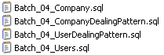

Step 4: Create a new sql file that will invoke the stored procedures and the 4 sql files. Follow the format below:

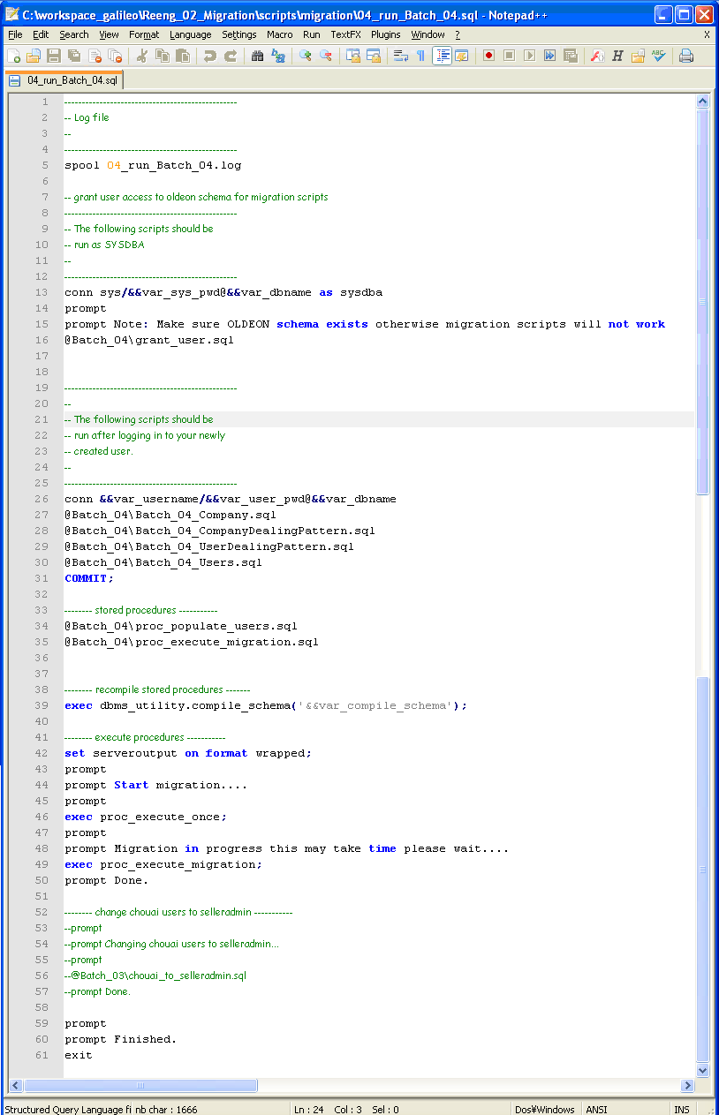
Step 5: Create the zip file that contains all the scripts.

